General Surgery Residency Program
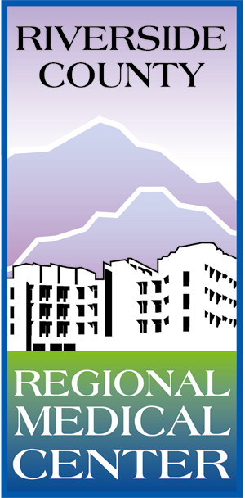
Case Report Requirement Approval Form

During the Surgical Education rotation, residents are required to meet with their mentor and get an interesting case to write a case report on. The interesting case should be one that can be presented at local, regional or national meetings or be published. The interesting case is to be complete by the end of your surgical education rotation. Please complete the form below and return it to Jenni Shieck no later than the end of the second week of this rotation.

Resident Name: _____________________________ Date: _______________________

Proposed Topic / Title: ______________________________________________________________

Goal of Interesting Case:______________________________________________________________
__________________________________________________________________________________
__________________________________________________________________________________

Current resources / literature on topic: _________________________________________________
_______________________________________________________________________________________________________________________________________________________________________

Projected completion date: ___________________________

Where are you going to submit case report (ie. What journals or meetings): ___________________
____________________________________________________________________________________

Signature of Resident Mentor: ________________________________________________________

After you have the above signatures, please submit this form to Jenni Shieck in the GME office.

Your Proposed Project Has Been Approved. □ Yes □ No

________________________________
Afshin Molkara, MD
Program Director
General Surgery Residency

